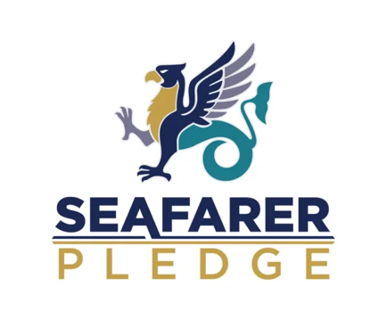

CERTIFICATE OF COMMITMENT

This is to certify that
[ COMPANY / ORGANISATION NAME ]

has formally signed the Seafarer Pledge, demonstrating a dedicated commitment to supporting and recognizing merchant seafarers and fishermen throughout their careers and transition ashore.

By signing the Seafarer Pledge, this organisation commits to:
- Welfare & Wellbeing: Enhancing practical support, health, and mental wellbeing resources for seafarers at sea and ashore.
- Practical Policy Action: Implementing fair, supportive workplace practices and transitional opportunities for seafaring personnel.
- Recognition & Appreciation: Promoting awareness of the essential contribution seafarers make to trade, economic security, and daily life.
- Continuous Improvement: Actively monitoring welfare commitments, sharing best practices, and fostering ongoing positive impact.

Person | Person    Chief Executive
Authorized Signatory (Organisation) | Merchant Navy Welfare Board (MNWB)

Date: Date

